

Introduction to Web Technologies

**Project Documentation**

Teacher: Nataliia Strukalo

Student: NYENGETERAYI MAWIRE

ID: w66964

Rzeszów 2023

TABLE OF CONTENTS

* DESCRIPTION OF SITE
* TECHNOLOGY USED
* NAVIGATION BAR AND DESRIPTION
* LINK TO SITE

**Description of topic, and objectives**

**Description of Site**

The website is an informative website for a mordern and ppular game called **Call Of Duty.** The game has grown in popularity which leads to a lot of updates for the game franchise. One of its most famous operations of the game is its online competition which are a good way to play with friends or compete for prize money on a professional level. What i am promoting on this site will be an update which will be made to the game for its upcoming season, giving fans a sneak peak of what the game has to offer.

**Technology Used**

To create the site i made it in the React JS framework,coupled up with typesrcipt,jsx, and css languages to produce the final layout of the website.

**Navigation Bar and Description**

The navigation bar is used to direct you to a certain section of the page.

1)The **Game** button navigates you to the top of the page which also works as the main hero page to give design and the reader the urge to want to see more of what the page has to offer.

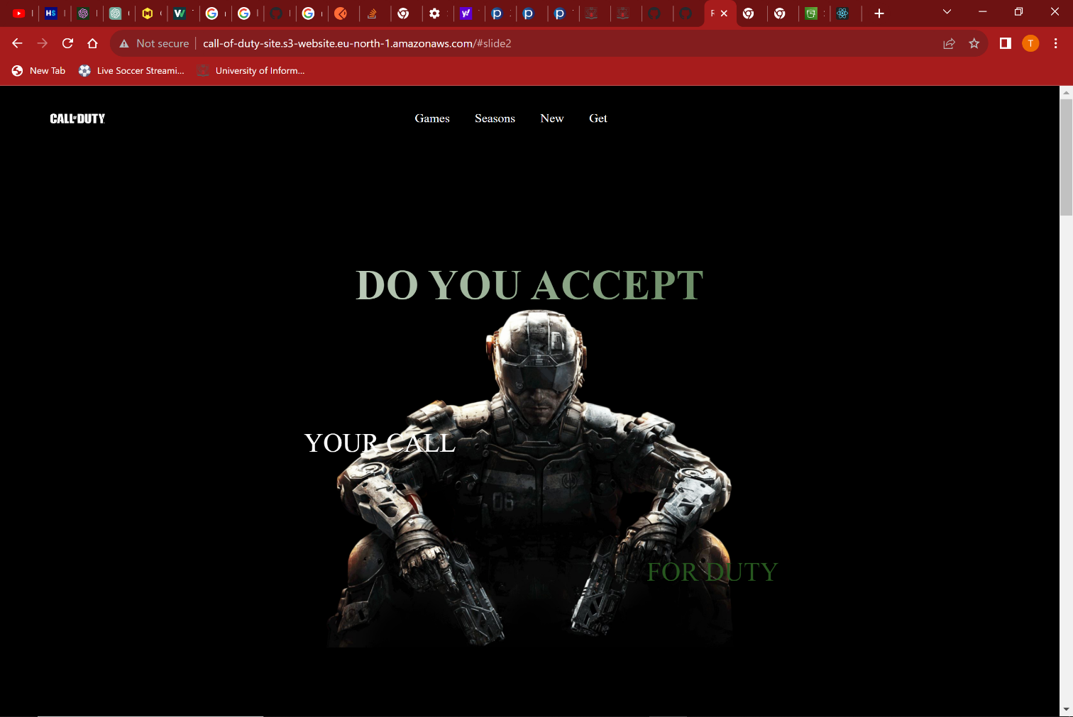**2)**The season section directs you to the main logo of what is being promoted which is the Season 3 of Call of Duty.

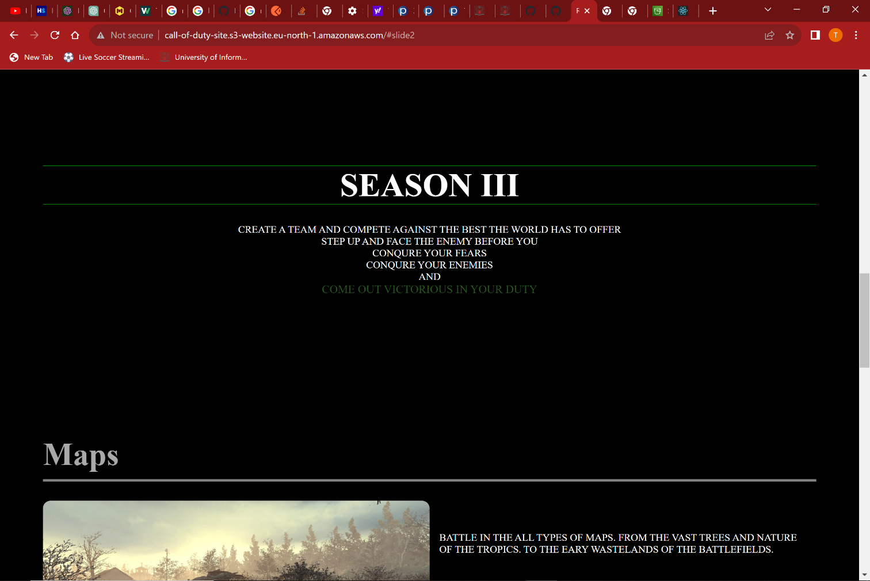

3)The new button in the nav bar directs you to a section of the page which shows you the what the new update has to offer from maps to vehicles and weapons.

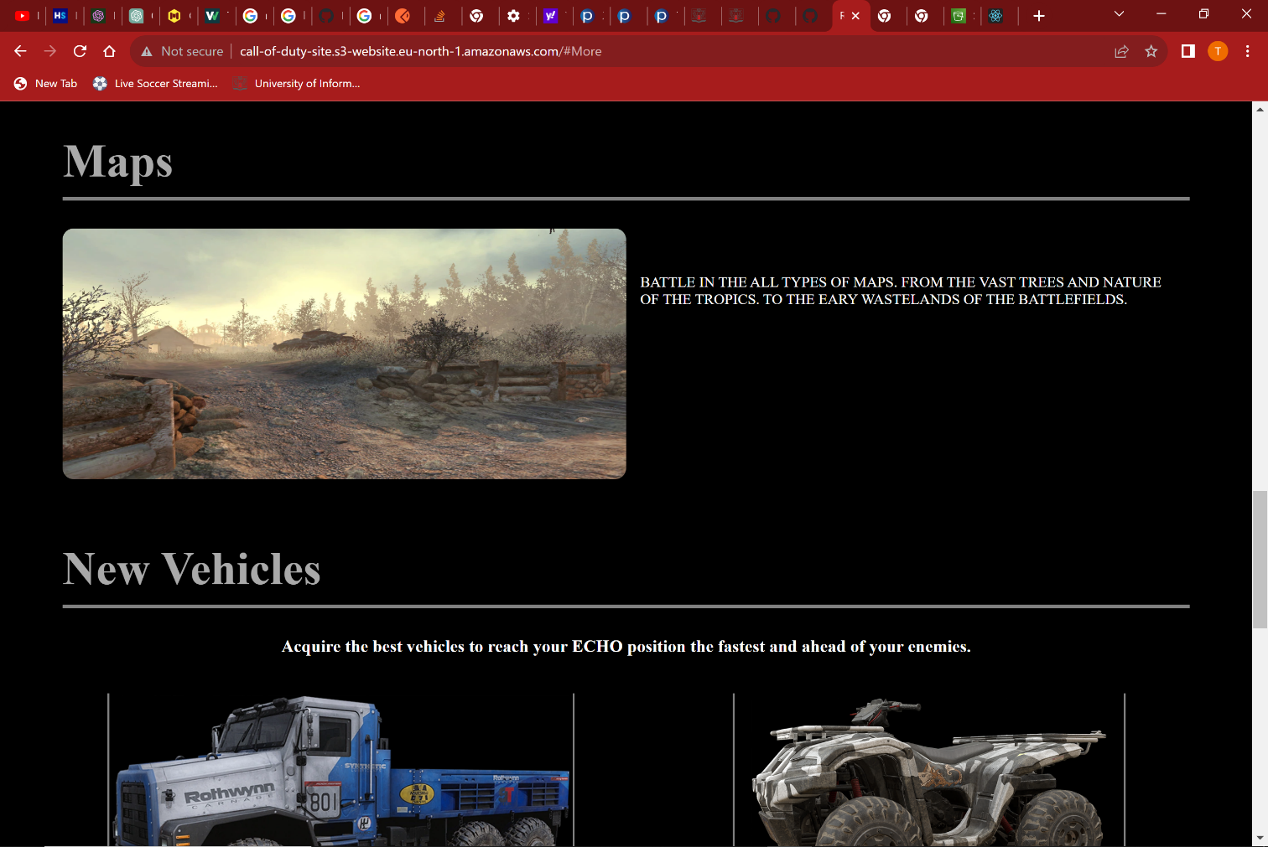

4)The get button in the nav bar directs you to a sectoin of the page were you will be able to get the new update and as well the game if you do not have at all. If you over over the images the pointer cursor will change and on click user will be sent to a new website were they are able to get the new game(Disclaimer in this part i linked the page to official game sites. I did not make the other sites)

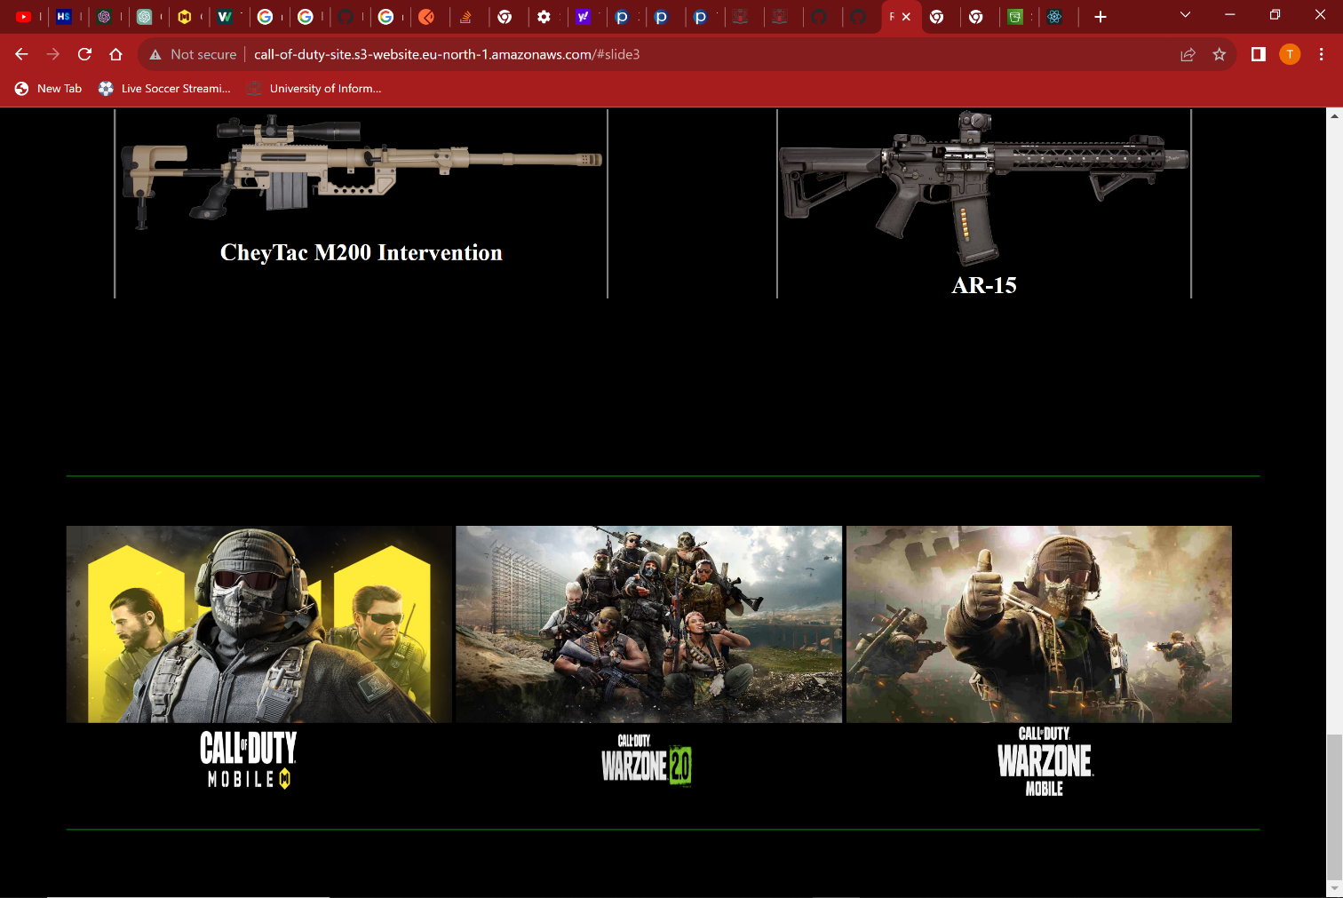

**Link to the site**

http://call-of-duty-site.s3-website.eu-north-1.amazonaws.com